FALLARM Technical Report

Capstone Project Submitted to

The School of Engineering

In Partial Fulfillment for the

Degree of Master of Science Computer Science

By

Aditya Ghadigaonkar 11101

Anusha Eppakayala 10750

Mandakini Saranu 10674

Phanindhar Repala 12414

Rohini Mukkala 10517

Prepared Under the Direction of Dr. Henry Chang



School of Engineering

Northwestern Polytechnic University

47671 Westinghouse Dr., Fremont, CA 94539

May 2015

# ACKNOWLEDGMENTS

We profoundly thank Professor Henry Chang for his inputs in the following areas:

1. Improving our understanding of business requirements.
2. Design and model a software project.
3. Technical knowledge required in the implementation.
4. Teaching us the networking concepts, and Integrating with Android

His constant urge to make a student to perform well is an added advantage.

Also we are grateful to our family members and other team members without their support and encouragement this project would not be successful.

# ABSTRACT

According to a health report published by Centers for Disease Control and Prevention nearly 1 in every 3 people over age of 65 suffer from severe injuries caused by fall (CDC, 2009). This fall risk factor increase with an increase in age due to change in sense of balance, slow reaction time, mussel weakness etc. Hospitals have incorporated techniques to prevent reduction of fall . Prevention of fall needs a pro active approach from everyone including patient and staff. Since many elderly individuals live alone, remote monitoring system would be a solution to watch for patient activity and send alert message to caregivers directly on their device upon detection of an adverse event .

**Table of Contents**

INTRODUCTION 6

* 1. The Concept 6

DESIGN 7

* 1. Introduction 7
  2. Use Case Diagram 7
  3. Class Diagram 9
  4. Sequence Diagram 11

IMPLEMENTATION 14

TEST RESULTS……………………………………………………………………………

ENHANCEMENTS IDEA 16

CONCLUSION…………………………………………………………………………………

BIBLIOGRAPHY 18

# Introduction

FallArm is a contemporary technology to prevent accidental falls among both hospitalized patients and the elderly, and help prevent and detect falls. This device will be used within the hospital environment and the hospital staff will use the software to monitor the patients. "FallArm" will continuously sense acceleration and orientation patterns and send this data to server which analyze it and classify risk. This risk class is conveyed back to patient as a feedback. Also the system reports any adverse events and alert is send directly to caretaker. Caretaker/staff can login to website to get full details about the incident or simply to analyze patient data.

This project focuses only on the software part, which in turn can be broadly categorized into three areas:

**Internet programming** – to develop a client-server model where the sensor will directly communicate with the server to provide the device data and the client interface will be used by the hospital staff to view, track patient’s information, and process the data.

**Network programming**–socket programming to enable communication between the client and the server.

**Database** – to hold the data related to the system at the server. This will include information about the user profile of the clients, the information received from the device.

# Design Section:

# Use Case Diagram

In Visual Studio Ultimate, a use case diagram summarizes who uses your application or system, and what they can do with it. A use case diagram acts as a focus for the description of user requirements. It describes the relationships between requirements, users, and the major components. It does not describe the requirements in detail; these can be described in separate diagrams or in documents that can be linked to each use case.



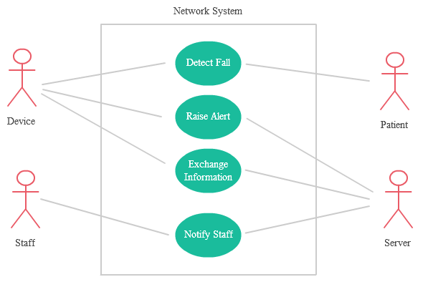

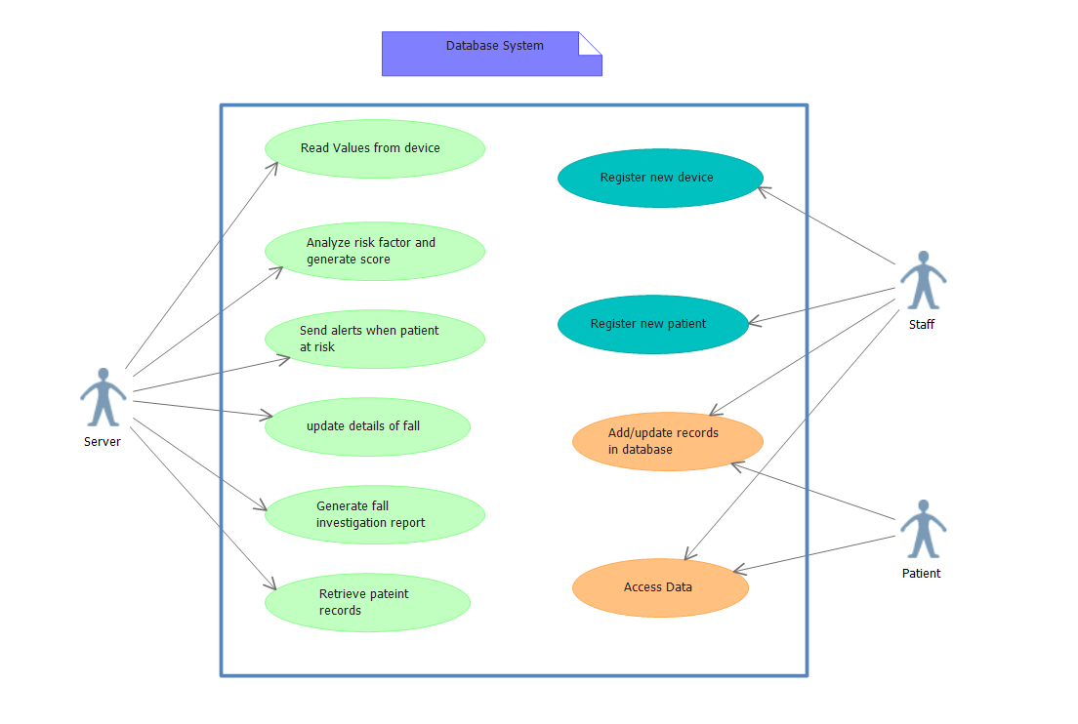

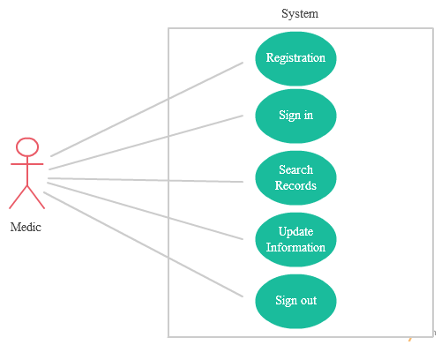

**Class Diagram:**

A UML class diagram describes the object and information structures used by your application, both internally and in communication with its users. It describes the information without reference to any particular implementation. Its classes and relationships can be implemented in many ways, such as database tables, XML nodes, or compositions of software objects. 

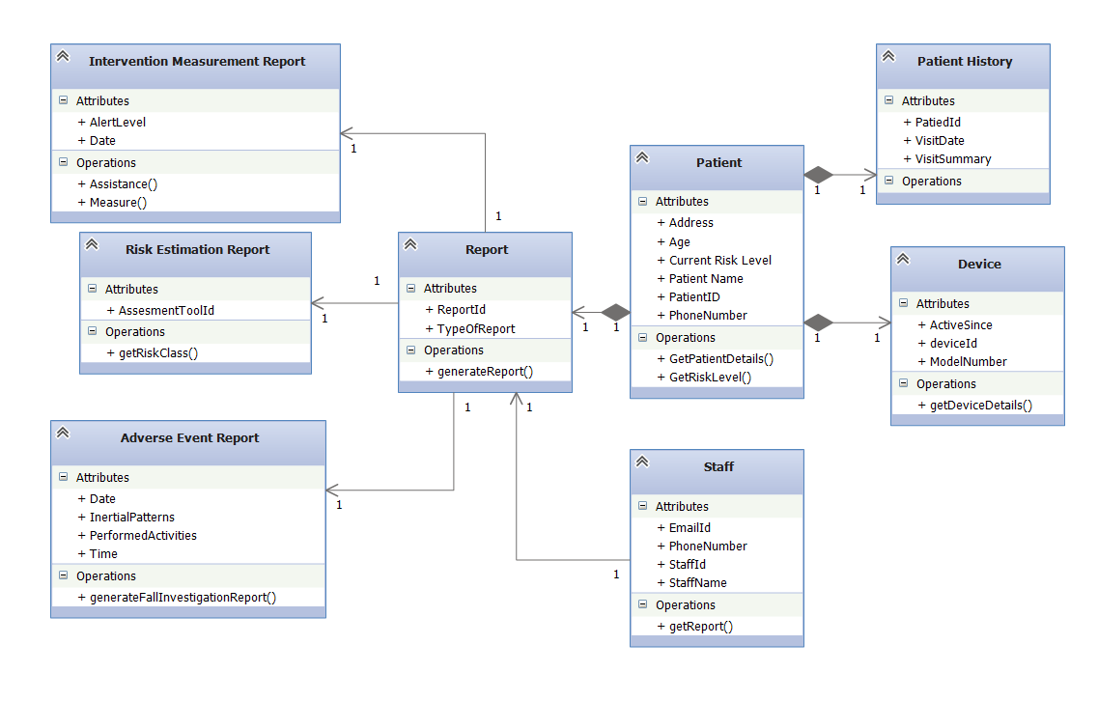

**Sequence Diagram:**

A sequence diagram shows an interaction, which represents the sequence of messages between instances of classes, components, subsystems, or actors. Time flows down the diagram, and it shows the flow of control from one participant to another. The diagram shows example instances and events, instead of classes and methods; more than one instance of the same type can appear in the diagram, and more than one occurrence of the same message can appear also.

There are two kinds of sequence diagram:

* Code-based Sequence Diagrams can be generated from .NET program code, and can be placed within any project. For more information, see Visualize Code by Generating Sequence Diagrams.
* UML Sequence Diagrams form part of a UML model, and exist only within UML modeling projects..

The two kinds of sequence diagram are similar, although a few of the properties of the elements are different.



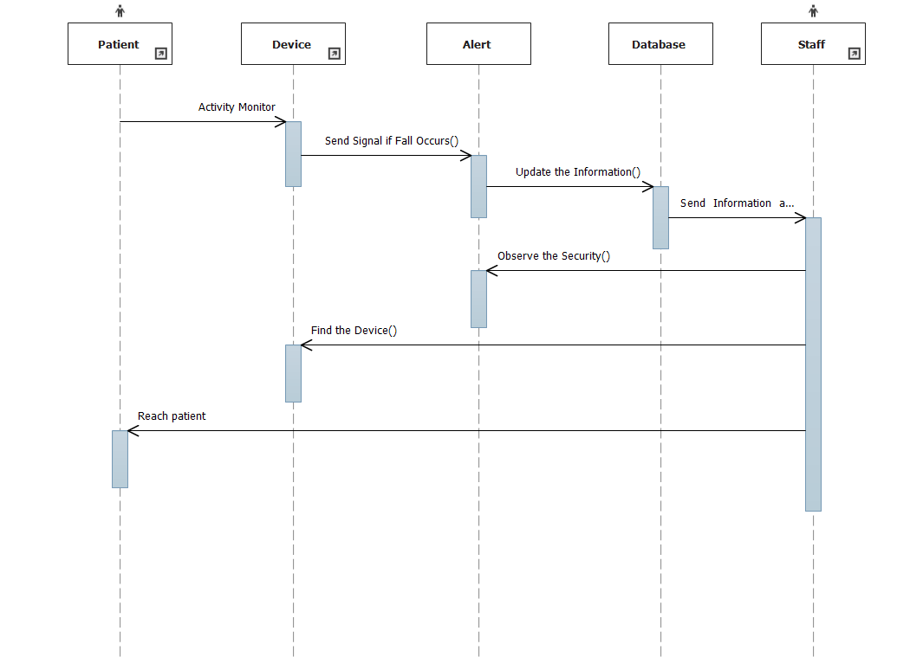

**Implementation**

**Sending Alert email/SMS**

From android device, two information will be sent to the server side, one is patient motion inflammation which include 3 number that represent accelerometer data and 3 number that represent orientation data, the other information is patient ID.

Java Mail API is used to send alert messages to staff and it is sent via Gmail SMTP server using ssl connection. Sender's email and password is authenticated and email is sent to staff email id retrieved from database. The message includes patient id.

**Test Result**

**Enchancement Idea**

**Conclusion**

Fallarm software is developed to help patient in case of an emergency in the situation of fall and also to get feedback about his/her activity in the form of risk report. We

provided an alert email/SMS (Short Message) from device to web browser which hospital staff will pay attention. According to the risk report hospital staff can contact patient to see if they need help. The software will store history of each & every activity pattern received from device and also a report on each adverse effect. Using web browser staff can retrieve & check patient information. The complete software package is successfully implemented and available for service.

**Bibliography**